FJFC TEAM PAGES – Instructions for logging in and updating.

The team pages have been created using Wordpress blog software. The advantage of using Wordpress is that the pages are much easier to update than the “old” pages and there is no requirement to use HTML software. All you need is a computer with internet access.

Each team page contributor must be set up as Wordpress Editor by the FJFC Website Administrator. Editors will receive an email from Wordpress providing a username, a password and a hyperlink to the FJFC Team Pages Dashboard.

1. When you receive the email from Wordpress, click the hyperlink in the email to display the log-in screen (see below). Enter your username and password, tick “Remember Me”, then click “Log In”. (Tip – copy the password from the email and paste into the password field in the log-in screen)

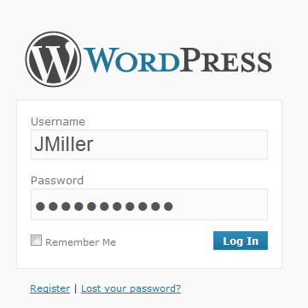

1. The FJFC Team Pages Dashboard will display. (Add this to your Favourites so that you can find it again) Under the Content column, click the “Pages” item (highlighted in the red box below) to display the list of Team Pages.

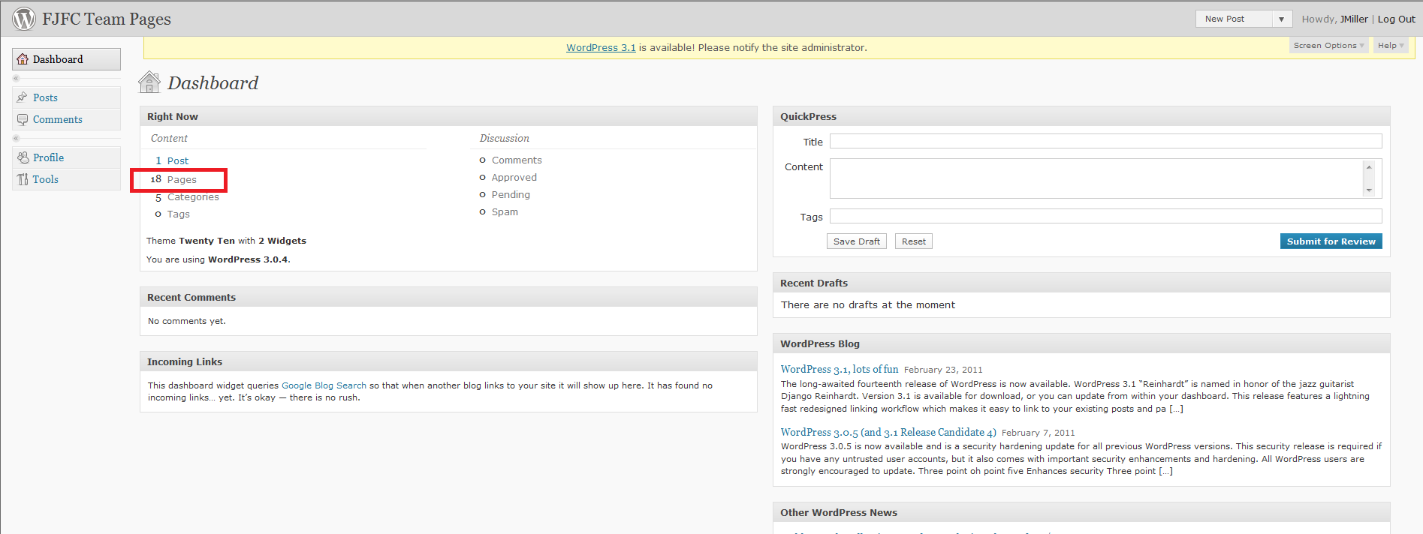

1. As a team page Editor, you will have access to all team pages. It is critical that you only update the team page(s) that you are responsible for. To start editing, hover the cursor over the list item to display the update options. Select “Edit” to open the page.(See example below)

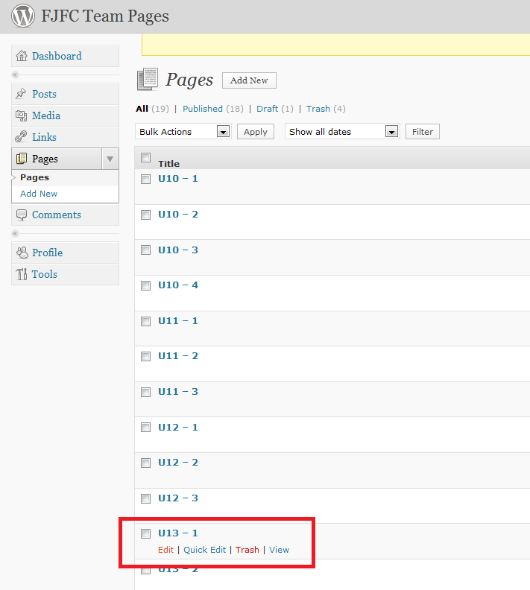

1. From this point on its reasonably straight forward. Text can be typed directly into the page.

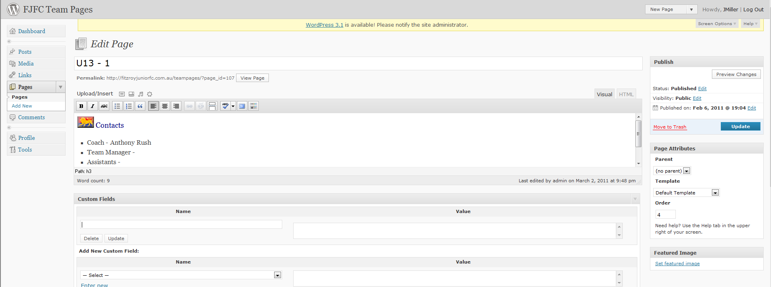

1. Use these buttons to format text, load photos etc.

This button shows/hides the lower row of buttons

This button allows you to toggle to full screen view

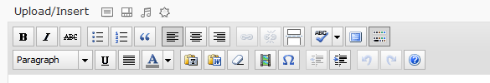

1. When you have updated the page and you’re ready to publish, click the Update button. Changes will not be visible on the page until this button is clicked



1. Some dos and don’ts.
   * Don’t load excessive numbers of photos onto the page ie no more than 6 at any time. If you want to share large numbers of photos, then load them onto a database designed for that purpose (eg [Flickr](http://www.flickr.com/)) and then insert a link to the photo set into the page. **(Note; the “featured image” in the banner at the top of the page can be changed so feel free to load a relevant team photo. This option is available while loading the image ie “Use as Featured Image”. The featured image does not need to be compressed but a maximum 2mb can be loaded )**
   * Don’t load videos. If you want to share videos then please load to an appropriate database (eg YouTube) and insert a link into the page.
   * Don’t create new pages or posts. (You may see these options on the dashboard). If you believe you need to create a new page then please ask the Administrator first.
   * Don’t experiment too much with formatting. Try to keep the look consistent with other team pages.
   * Don’t provide log-in details to others. (If you must, one or two others maybe, but log-in details should not be widely distributed)
   * Do compress photos before loading. If you’re not sure how to do this then please ask the FJFC Web Site Administrator [david.m.miller@optusnet.com.au](mailto:david.m.miller@optusnet.com.au) (If a photo is to be used as the featured image in the banner then it does not need to be compressed but cannot be greater than 2mb)
   * Do remember that the team pages are publicly viewable, so be mindful of the privacy of players and team officials (get their ok to publish contact details) and be respectful to opposition teams.
   * Do be very careful that you only update the page(s) that you are responsible for.
2. To insert a hyperlink to another website (eg to Picassa or Flickr).

* On the target website, highlight the URL (ie page address

